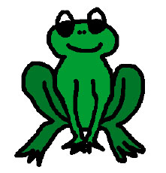

My Froggy Care Book

Name______________________

What the eggs look like

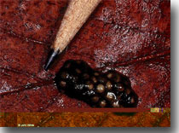

Draw a Picture of the Frog

What type of frog do you think the eggs will become and why?
___________________________________________________________________________________________________________________________________________________________________________________________________________________________________________________________________________________
The Life Cycle of a Frog
The Frog's Natural Habitat
What does this frog eat? Does what it eats change as it grows?
__________________________________________________________________________________________________________________________________________________________________________________________________________________________________________________________________________________________________________________________________________

What do you need if you are going to care for this frog at school (in captivity)?
_______________________________________________________________________________________________________________________________________________________________________________________________________________________________________________________________________________________________________________________________________________________________________________________________________________________________________________________________________________________________________________

